## horizontal line



Assignment # 1

CS322 - SC - Software Construction

**─**News Vine (Case Study # 4)

**Group no. 1**

**Team Members:**

1. Awais Ali ( Team Lead ) - 04072212008
2. Hania Naeem- 04072113009
3. Ghulam Anwar - 04072013029

**Submission Date:** 04-03-2024 09:00 AM

Signature Page

Quaid e Azam University

Department of Computer Science

**Social Platform Case Study**

The submitted document titled “Social Platform” is authentic work submitted by Awais Ali(Team Lead) ( 04072212008 ), Hania Naeem ( 04072113009 ), Ghulam Anwar ( 04072013029 ) conducted at Quaid-I-Azam University, Islamabad. The document strictly follows the IEEE guidelines and ensures secure coding practices. All data from any source is referenced in the documentation. This document is not submitted to any platform but is a genuine combined effort of all our team members.

**Signature:**

Awais Ali (Team Lead) 04072212008

Hania Naeem 04072113009

Ghulam Anwar 04072013029

Date: 04-03-2024

Sign of instructor______________

**Change of History**

**Version 1.0** - Scope, Objectives, and deliverables submitted in Lab.

**Version 1.1** - Complete Project Plan Documentation.

**Preface**

In an era where digital platforms dominate news consumption, the development of a dedicated social news platform is imperative. This case study embarks on crafting such a platform, aimed at ordinary web users seeking authentic news experiences. Through user ratings, the platform strives to distinguish credible sources from misinformation, empowering users with informed choices. With robust search functionalities, users can navigate news articles by date, location, category, or content, tailoring their consumption to personal preferences. Additionally, the platform emphasizes user engagement, offering features like registration, multimedia news posting, commenting, favoriting, and user following, fostering a vibrant community. Ultimately, this platform endeavors to reshape news dissemination, fostering transparency, accountability, and trust in the digital news landscape.

**Table of contents**

1. Project Overview…………………………………………………………………………………...……………………………………………..05
   1. Project Summary……………………………………………….…...……………………………………………………………...05
   2. Purpose, Scope and Objectives ………………………………...……………….……………………………………………..06
   3. Assumptions and Constraints …………………………...………………………………………………….…………..……...08
   4. Project Deliverables…………………………...…………………………………………………………………..……….……...08
   5. Schedule Summary …………………………...…………………………………………………………………..…….………...09
2. References ………………………………………………………………………...……………………………………………….……………...09
3. Definitions ………………………………………………………………………………………………………………………………………..09
4. Project Context ………………………………………………………………………………………………...………………………………. 10
   1. Process Model ……………………………………………………………………………………………………………………….10
   2. Methods, tools, and techniques ……………………………………………………..……………………………………..…10
   3. Product acceptance plan ………………………………………………………………………………..………………………..11
5. Project Planning ………………………………………………………………………………………………………………..………………13
   1. Project Work Plans …………………………………………………………………………………………………………….….13
      1. Work Activities …………………………………………………………………………………………………………13
      2. Schedule allocation …………………………………………………………………………………………….…….15
      3. Resource allocation …………………………………………………………………………………………….…….15

8. Supporting Process Plans …………………………………………………………………………………………………………...……...16

8.1 Risk Management ………………………………………………………………………………………………..…………..16

**List of Figures:**

4.1 Agile Process Model ……………………………………………………………………………………………………………………... 09

5.1.2 Schedule ……….……………………………………………………………….………………………….…………………….............. 11

5.1.3 Resources ……………………………………………………………………………………………………………..………………….. 11

**List of Tables:**

8.1 Risk Management …………………………………………………………………………………………………..…………………….11

# Project Overview

## Project Summary

The project aims to create a social news platform where users can post and read news. News authenticity is determined by user ratings, with interesting content receiving higher ratings and fake news being downvoted. Users can search for news based on various criteria, register, post news with multimedia, comment, mark favorites, and follow other users for updates. Overall, the platform encourages authentic news sharing and user engagement.

1.2 Purpose, Scope, and Objectives

### **Purpose**

1. Outline the development of a social platform focused on news sharing.
2. Enable ordinary web users to post and consume news content.
3. Establish news authenticity through user ratings, promoting genuine information dissemination.
4. Provide features for personalized news consumption and community interaction, including search functionalities, registration, commenting, favoriting, and user following.

### **Scope**

1. **Stakeholder**
2. Users
3. Administrators
4. Developers
5. Content Moderators
6. **Functions**
7. News Posting: Users can submit news articles, including multimedia content such as images and videos.
8. News Consumption: Users can browse and read news articles posted by others.
9. Authentication: News authenticity is determined through user ratings, promoting credible information sharing.
10. Interaction: Users can comment on news articles, mark favorites, and follow other users for updates.
11. Search and Filtering: Users can search for news based on criteria like posting date, city, category, and content.
12. User Management: Administrators oversee user registration, profile management, and content moderation.

**3.Major Inputs:**

1. User-Generated Content: News articles, images, and videos submitted by users.
2. User Ratings: Feedback provided by users to determine the authenticity and relevance of news content.
3. User Interactions: Comments, favorites, and follows generated by user engagement.

**4.Major Outputs:**

1. Published News Articles: Credible and relevant news content available for consumption.
2. User Feedback: Ratings and comments reflecting user opinions on news articles.
3. User Engagement Metrics: Data on user interactions such as favorites and follows.
4. Platform Performance: Metrics on platform usage, including traffic, user registration, and content submissions.

### **Objectives**

1. **Data-Hiding:** The data of every user will be hidden from the other user, only he/she will be able to access that data.
2. **Accessibility and convenience:** Students will be able to access their data for course registration anytime without wasting any time while outside the department office, on their computer in the lab, or on their personal laptops.
3. **Scalability:**  Design the system to accommodate potential expansion to other university departments, allowing for a standardized and efficient course allocation process across the institution.
4. **Transparency and streamlining system:** Promote transparency by providing students with clear information about course availability, prerequisites, and registration status.
5. **Role-based access control: I**mplement role-based access control to ensure that students, teachers, and administrators can access only the functionalities relevant to their roles.
6. **Minimize the amount of paperwork:** Simplify and automate the course registration process to reduce manual administrative work and paperwork.
7. **User-Friendly Interface:** Create a user-friendly interface that enhances the user experience for students, teachers, and administrators.

## Assumptions and Constraints

1. **Software Constraints**
2. Integrated Project / Not stand-alone project.
3. Java For programming.
4. MS Word for Documentation.
5. Gantt chart on Project Libre.
6. Project Plan.
7. Desktop Application.
8. **Project Constraints**
9. Cost for the project.
10. Duration of 105 Days.

## Project Deliverables

* **Within Team:** 
  + Project Plan
  + Source Code
  + Gantt Chart
  + Analysis Model
  + Test Reports
  + Resources availability.
  + System Design.
* **To the End-User**
  + Final Product (Desktop Application).
  + Documentation.
  + Data backup and Recovery procedure.
  + Software Requirement Specifications.

## Schedule Summary

* 6 days for **Planning.**
* 21 days for **Analysis**
* 2 days for defining **Project deliverables.**
* 5 days for defining **use cases.**
* 4.5 days for **designing the Analysis model.**
* 21 days for **design.**
* 28 days for **development.**
* 17 days for **testing.**

# References

1. Management (International Standard ISO/ IEC/ IEEE 16326 2nd Edition- 2019
2. Code-complete-2nd-edition by Steve McConnell.

# Definitions

|  |  |
| --- | --- |
| **Terms** | **Descriptions** |
| SRS | Software Requirement Specifications: |
| UAT | User Acceptance Test |
| PMP | Project Management Plan |
| PMP | Quaid-e-Azam University |
| Java | Computer-based Programming Language |
|  |  |

# 4.Project Context

**4.1.Process Model**

When creating a social news platform, the Agile Model i.e. the scrum model is a well-suited choice. The reason for opting this model is due to its ability to adapt to continuous changes and ensuring the quality of the product. The required needs of the client can easily be met in time due its incremental nature. During development, effective risk management is done when a failure arises, that’s because of the close engagement among the members of the team.

**4.2.Methods, tools and techniques**

* **Method**

Object-oriented method is the right choice for the development of the social platform, it helps to organize the code better, keep things separate, share common features, handle different tasks easily, adapt to changes smoothly, reuse code, and work together with other developers. Furthermore, it guarantees the development of a robust, adaptable, and easily maintainable software solution.

* **Tools**

The tools used for development are given below:

* Project Libre: Used for project management.
* Microsoft Word: Used for documentation.
* Visual Studio Code: Used for coding.
* Microsoft Teams: Used for collaboration/submission.
* WhatsApp: Used for communication among the members.
* GitHub: Used for version control.
* Lucid chart: Used for creating flowcharts and diagrams.
* Adobe Illustrator: Used for graphic designing.
* XAMPP: Used for database development.
* **Techniques**
* Select the right process model and approach to develop the software.
* Document the functional requirements of the client
* Connect with the team members/conduct meetings.
* Track the progress of the project to ensure quality and effectiveness.
* Provide feedback and support in case of queries.

**4.3.Product Acceptance Plan**

|  |  |  |  |  |
| --- | --- | --- | --- | --- |
| Phase | Activity | Test Cases | Expected Results | Actual Output |
| Specify | Gather requirements from stakeholders | Stakeholders provide requirements | Clear and comprehensive requirements are gathered |  |
| Design | Design system architecture and user interface | Review system architecture and UI design documents | Architecture and UI design meet requirements |  |
| Build | Develop website and database backend | Ensure all required features are implemented | Website functions without errors |  |
| Test | Conduct unit, integration, and system testing | Perform unit tests on individual components | Components pass unit tests |  |
|  |  | Integrate components and conduct integration testing | Components integrate seamlessly |  |
|  |  | Conduct system testing on the entire platform | Platform functions as expected |  |
| Document | Document system functionalities and user manuals | Review system documentation | Documentation is comprehensive and easy to understand |  |
| Deliver | Deploy the social platform on a web server | Access the website and test registration, posting, etc. | Users can register, post news, comment, etc. |  |
| Modify | Implement any necessary changes based on feedback | Address feedback from stakeholders | Changes are implemented according to feedback |  |
| Maintain | Regularly update and maintain the platform | Test updates before deployment | Updates do not introduce new issues or break functionality |  |
| Review and accept | Review the entire project deliverable and non-deliverable products | Stakeholders review the final product | Stakeholders approve the final product for release |  |

**5.Project planning:**

**5.1.Project work plan:**

**5.1.1.Work Activities**

**(1) Project discussion:**

**(2) Planning:**

* Requirements gathering
* Scope and Objectives
* Scheduling the project
* Allocate the Resources

**(3) Review:**

* Discuss with team.
* Refine the problems.

**(4) Analysis:**

* Defining the Inputs and Outputs
* Define major functions.
* Define the constrains.

**(5) Defining project deliverables:**

* Discuss deliverables with team and client.

**(6) Designing Use-Cases:**

* Define the use case description and use case diagram.

**(7) Developing Analysis model:**

* Develop domain model.
* Make state chart diagrams.
* Make Activity diagrams.
* Make sequence diagrams.

**(8) SRS Development:**

* Define the SRS
* Review the SRS
* Refining the SRS

**(9) Design:**

* Setting Design Principles
* Draw Data Design

**(10) Prototyping:**

* Design the Interface prototype.
* Discuss the prototype.
* Refine the prototype.
* Design the Actual Interface
* Detailed interface design
* Review the interface design.
* Refine the interface design.

**(11) Development:**

* Connect the data to system.
* Refine the Front end.
* Develop the classes.

**(12) Testing:**

* Software testing by yourself
* Presenting the project
* Refining the project

**5.1.2.Schedule Allocation:**

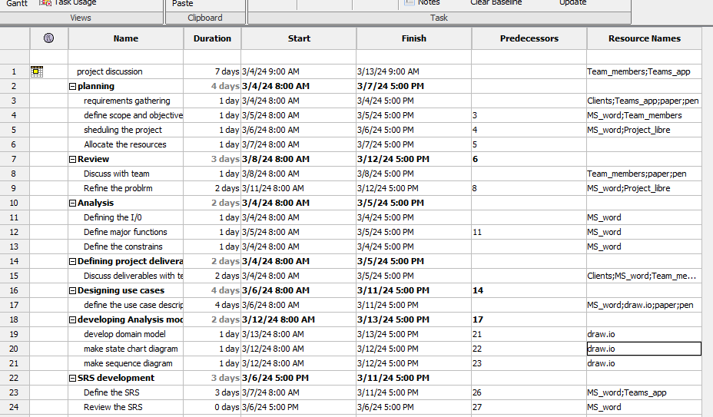

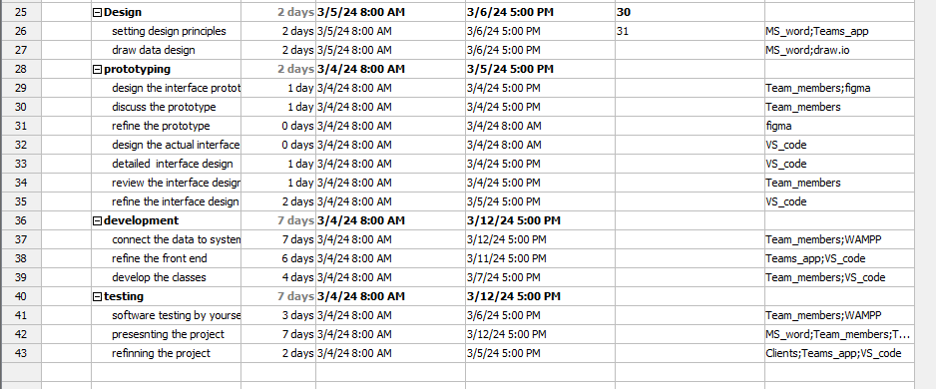

**5.1.3.Resource Allocation:**

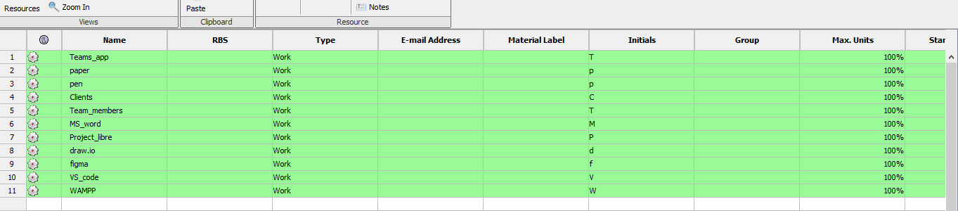

# 8.Supporting Process Plan

**8.1.Risk Management**

|  |  |  |  |
| --- | --- | --- | --- |
| Risk | Probability | Impact | RMMM |
| The lack of user adoption | There’s a 70% chance for this risk to happen. | Decreased platform usage and engagement, potentially leading to project failure. | Conduct user research, offer incentives, and address user feedback promptly to enhance platform usability. |
| The spread of misinformation | There’s a half and half chance, i.e. up to 50% for this to occur. | Erosion of credibility, loss of user trust, and potential legal liabilities. | Implement detection algorithms, encourage user reporting, and have a dedicated team for content verification. |
| Any technical glitches | Same as above | Interruption of service, user frustration, and negative impact on user experience. | Invest in reliable hosting, monitor server performance, and have backup systems to minimize downtime. |
| The data privacy concerns | There’s a medium chance for this to occur. | Breach of user privacy, loss of trust, and legal ramifications. | Implement robust data protection measures, obtain user consent, and regularly audit data handling practices. |
| Security breach | There’s a 50% chance for this to happen. | Compromised user data, loss of trust, legal consequences, and damage to reputation. | Use strong security measures, conduct regular audits, and have a response plan for swift action in case of breach. |
| Any scalability Issues | Same as above | Inability to handle increased user traffic and data volume, leading to system crashes. | Implement scalable architecture, conduct load testing, and invest in infrastructure to accommodate growth. |